**SYNOPSIS REPORT**

**On**

**Online Streaming Platform with AWS as Backend**

**Submitted by:**

|  |  |  |  |
| --- | --- | --- | --- |
| **Astha Kumari** | **Devanshu Pathak** | **Devang Tyagi** | **Gaurav Kumar** |
| **500076107** | **500075792** | **500077078** | **500076068** |
| **R110219027** | **R110219043** | **R110219041** | **R110219053** |
| **BTech-CSE CCVT** | **BTech-CSE CCVT** | **BTech-CSE CCVT** | **BTech-CSE CCVT** |



***Under the guidance of***

### Mr Vijay Prakash Assistant Professor Department Of Systemics

**School of Computer Science**

**TABLE OF CONTENTS**

|  |  |  |
| --- | --- | --- |
| **Sr.No** | **Content** | **Page No** |
| **1** | **Abstract** | **3** |
| **2** | **Introduction** | **4** |
| **3** | **Literature Review** | **5** |
| **4** | **Problem Statement** | **6** |
| **5** | **Objective** | **6** |
| **6** | **Methodology** | **8** |
| **7** | **Pert Chart** | **9** |
| **8** | **System Requirement** | **9** |
| **9** | **Area Of Application** | **10** |
| **10** | **References** | **10** |

**MAJOR -1**

## PROJECT TITLE:

**Online Streaming Platform with AWS as Backend.**

## ABSTRACT:

User Generated Content (UGC) forms the backbone of many popular online streaming services. As internet access grows, more and more people are using apps and services to share their personal experiences with a global audience.

In recent years, live video streaming services featuring user-generated content have become an effective way to connect with others who share similar interests or are experiencing broadcaster-mediated events.

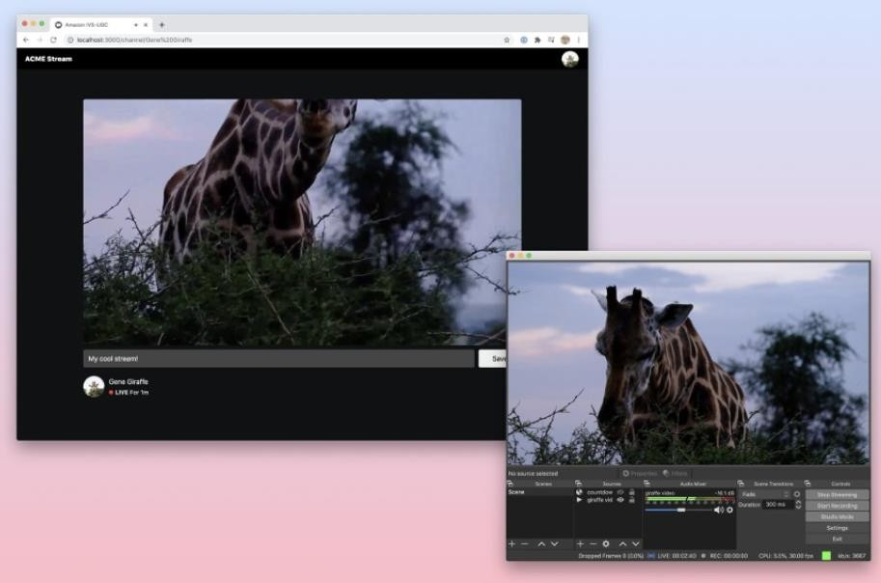

Fig 1. Reference Online Streaming Platform

It is Live streaming is becoming very popular, but building and maintaining a large scale global live video distribution system can be challenging. It's about providing a platform for streaming online using AWS services and an interactive interface for user interaction as indicated in the Fig 1 below [1].

## INTRODUCTION :

## An “Online Streaming Platform” is an on demand online entertainment source for TV shows, movies and other streaming media. There is a substantial need of creating static buckets with transcoded videos to deal with the problem of network latency with respect to the availability zone in which the server for the same application is hosted . Hence the application deals with the same methodology of creating transcoded buckets using the lambda triggers to solve the problem in real time environment .

Many businesses and organizations require secure streaming solutions. In particular, groups such as healthcare institutions, universities and schools, corporations, OTT and media companies, intellectual privacy and piracy organizations, lawyers and government agencies must consider security an absolute necessity [4] .

AWS provides an easy way to stream video using Amazon S3 and Amazon CloudFront. I don't want to set up a server to convert the video to another output format. Fortunately, in this post- cloud world, AWS offers serverless options. This post shows how to build a fully automated and secure video-on-demand solution using AWS services as indicated in the figure 2 below [3].

#### Architecture Overview

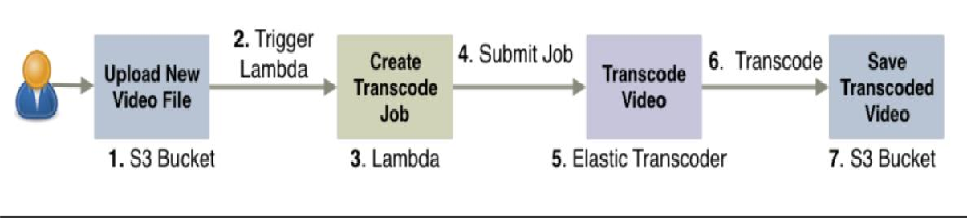

Fig 2 : The overall flow of the process for uploading files.

Today, more and more businesses are using video streaming platforms to host and share their content. Both live streaming and video on demand (VOD) are very powerful tools that businesses and businesses can use to increase revenue, communicate effectively, and reach audiences.

**Literature Review:**

Agarwal et. al [1] proposes online streaming function presented to the end user or the target audience is continuously received by the provider with the most central and well- known services such as Amazon EC2 and Amazon S3. These service are much faster, scalable and cost-effective than building a physical server farm. In the current system, media streaming is done on computers and is not used for common people. That is why this system is designed to enable media streaming to any user using smartphones. The main objective of this proposed system "Cloud Enabled" streaming using Amazon Web Services" is to stream media files through a media server using AWS. media server uses Amazon EC2 server to stream and store multimedia files. Storage of multimedia files is done in EBS and Simple Storage Service (S3) maintains a backup of these files.

Li et. al [2] proposes that cloud technology is adopted due to the great features provided to video stream providers, such as high flexibility of using virtual machines and storage servers at low prices. Video streaming providers prepare multiple formats of the same video to satisfy the device specifications of all users. Video streams in the cloud are either transcoded or stored. However, storing all video formats is still expensive. In this research, we develop an approach that optimizes cloud storage. The proposed method reduces the cost of using cloud services by up to 22%.

Iturriaga et. al [3] states that when we transcode the videos on Amazon Elastic Cloud Computing (EC2) or Virtual Machines (VMs) to further study realistic cloud settings with fine-tuned configurations. Our experiments show the superior performance of some codecs and the effects of machine configurations on transcoding tasks duration. Which generalizes to the idea of a benchmark for practitioners and researchers considering online transcoding in real-time multimedia applications .

# Problem Statement :

The global Online Streaming platforms market is currently rising with almost USD 45.1 Billion in 2021 and is expected to somewhat cross a value of USD 123.67 Billion by 2028 in accordance to a report by Gartner Quadrant, hence there is a need of establishing professional streaming workflows without worrying about the hardware and technical challenges along with on premises infrastructure scaling .

Online streaming cloud platforms gives us an advantage of both end to end video streaming capability reduced the considerable operation costs large scalable storing capability.

**Objective :**

In this project, we will build a video sharing website with user authentication and features of uploading and downloading large video files.

#### Sub-Objective:

1. To design an encoding pipeline that converts uploaded videos to web-friendly mp4 format
2. To design a push-based event-driven updates for website. Users can automatically watch new videos without having to refresh their browser Ability to play video files hosted in scalable cloud storage as shown in the figure 3 below.

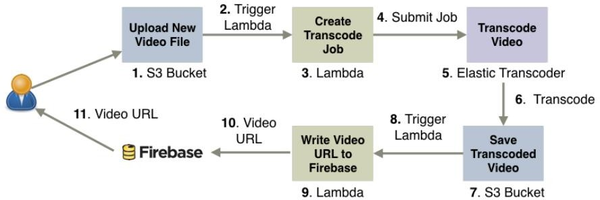

# Methodology:

Fig 3 setting up encoding pipelines

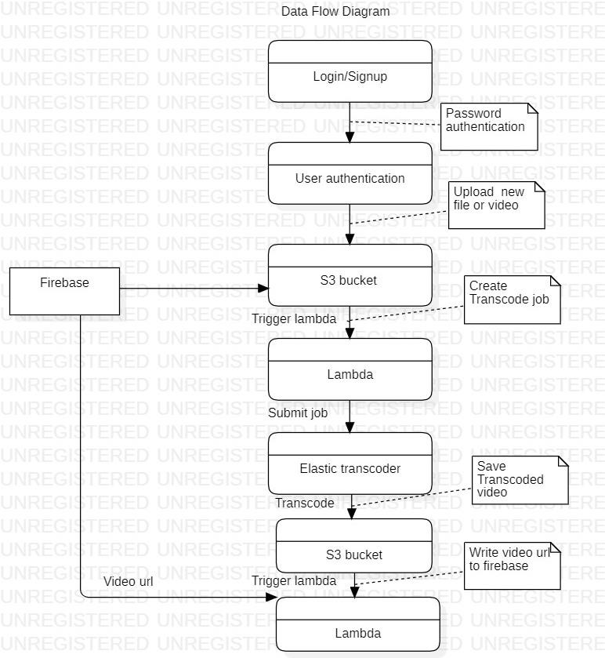

Fig 4 : The data flow diagram of the process involved

* + Basically we start with that S3 (requires two bins). The first bucket serves as the upload bucket for new videos. The second bucket contains the encoded videos placed there by Elastic Transcoder.
  + Additionally, we need to create an IAM role for our future Lambda function. This role allows your functionality to interact with S3 and Elastic Transcoder.
  + Now you need to set up an Elastic Transcoder pipeline to encode video to different formats and bitrates.
  + We are about to create our first Lambda function, but we don't provide an implementation yet. Finally, we'll explore the Lambda function in action and deploy it to AWS.

# Pert Chart:

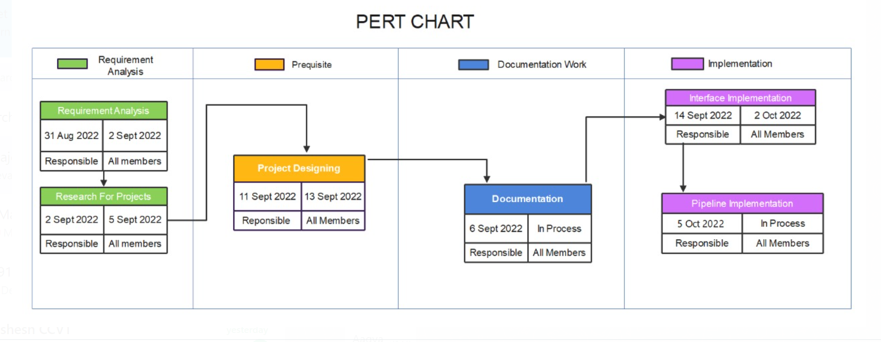

Fig 5: The representation of timeline followed.

# System Requirement:

### Hardware requirements:

* 4GB RAM (minimum)
* Windows 10 / MacOS (Catalina) / Linux-Ubuntu

### Software requirements:

* Chrome/ Firefox/Edge

# Area of Applications:

There are numerous reasons why live streaming have various application in the business. driven scenarios some of them are as follows-:

* + Companies can also use live broadcasts to enhance and maximize direct communication with customers and community partner .
  + Live streaming an event allows you to reach and interact with more people across the world. One of the top advantages of live streaming is that you can connect with a wider, worldwide audience.
  + A live streaming service for businesses allows you to present a professional front when sharing live video content.

# References :

1. Agrawal, P., Zabrovskiy, A., Ilangovan, A., Timmerer, C., Prodan, R., “Fastttps: fast approach for video transcoding time prediction and scheduling for http adaptive streaming videos.” Clust. Comput. **24**(3), 1605–1621 (2021).
2. Li, X., Darwich, M., Salehi, M. A., & Bayoumi, M. (2021). A survey on cloud-based video streaming services. In Advances in Computers (Vol. 123, pp. 193-244). Elsevier.
3. Iturriaga, S., Goñi, G., Nesmachnow, S., Dorronsoro, B., & Tchernykh, A. (2018, September). Cost and QoS optimization of cloud-based content distribution networks using evolutionary algorithms. In Latin American high performance computing conference (pp. 293- 306). Springer, Cham.
4. Agrafiotis, I., & Kul, G. (2021). Guest Editorial: Special Issue on Advances in Insider Threat Detection. J. Wirel. Mob. Networks Ubiquitous Comput. Dependable Appl., 12(2), 1-2